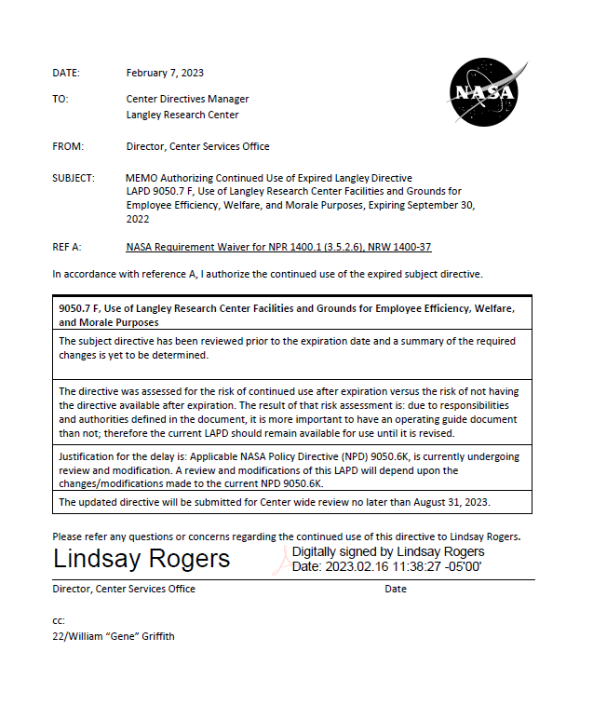
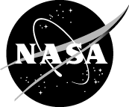
Langley Policy Directive

LAPD 9050.7 F
Effective Date: 8/18/2017 Expiration Date: 8/31/2022

Subject: Use of Langley Research Center Facilities and Grounds for Employee Efficiency, Welfare, and Morale Purposes
Responsible Office: Office of Human Capital Management (OHCM)

POLICY
It is the policy of LaRC to ensure that:
- When not being used for official purposes, NASA Langley Research Center (LaRC) facilities and grounds may be used to support activities directly contributing to the efficiency, welfare, and morale of Center employees. The LF 268, NASA Langley Research Center Facility Usage Request, has a list of facilities primarily affected by this policy. However, this policy applies to all facilities located on LaRC, even those not specifically identified on LF 268. Any question regarding the use of other facilities not set forth in the LF 268 will be determined on a case-by-case basis consistent with this policy.

- The following employee groups may use facilities and grounds for efficiency, welfare, and morale purposes as set forth in this policy:

  - The LaRC civil servant workforce;

  - An individual LaRC organizational unit (OU);

  - LaRC Exchange groups, teams and activities; and

  - LaRC contractor organizations.

NOTE: Family members and guests of LaRC employees, retirees, contractor employees, and official visitors may participate in employee efficiency, welfare, and morale events.

- Official Functions by the Office of the Director, core mission functions, and Center-wide morale activities that are scheduled 90 days in advance generally take precedence over all other activities. Other activities will be scheduled on a first-come, first serve basis in the following order of precedence:

  - Center-wide activities;

  - Morale activities conducted by specific LaRC organizations; and

Page 1 of 4

Verify the correct revision before use by checking the LMS Web site.

  - All other NASA-affiliated activities consistent with this policy.

- LaRC civil servant employees may also hold modest celebrations (such as employee retirements, career advancement recognition events, birthdays, showers, or other special occasions) in work areas. Guests or visitors may be hosted in unclassified common areas only. All activities must be in compliance with facility use policies. Such use may be held during normal business hours and with supervisory approval.

- Employee groups as stated above in paragraphs 1.b. 1-4 may not use official or common facilities or grounds for profit-making or fundraising events or activities without first coordinating with the Office of Human Capital Management (OHCM) and the Office of Chief Counsel (OCC). Questions regarding contractors should also be coordinated through the Office of Procurement.

- In implementing this policy, the Center will:

  - Comply with Federal law, Federal regulations, and NASA policy governing access and the use of its facilities and grounds;

  - Not engage in activities that unduly compete with local merchants;

  - Not adversely impact official functions; and

  - Collaborate and coordinate to the maximum extent possible to resolve scheduling conflicts by seeking use of all alternative Center space for meetings, activities, and conferences.

APPLICABILITY

  - This directive is applicable to NASA Langley Research Center.

  - In this directive, all mandatory actions (i.e., requirements) are denoted by statements containing the term “shall.”

AUTHORITY

51 U.S.C. sec.20113(c)(5) of the National Aeronautics and Space Act.

APPLICABLE DOCUMENTS AND FORMS

  - NPD 9050.6, NASA Exchange and Morale Support Activities
  - NPD 1001.0, NASA Strategic Plan

  - NPR 1600.4, Identity and Credential Management
  - NPR 1800.1, NASA Occupational Health Program Procedures
  - LAPD 1150.2, Councils, Boards, Panels, Committees, Teams, and Groups
  - LAPD 1600.7, Langley Research Center (LaRC) Visitor and Temporary Access Policy
  - LAPD 9050.8, Use of Langley Research Center Facilities for Activities for Non-
Official Events
  - LF 268, NASA Langley Research Center Facility Usage Request

  - LF 103, NASA Langley Research Center Security Services Branch (SSB) U.S. Citizen Visitor Badge Request Form (29 days or less)

RESPONSIBILITY

  - Authorized users and sponsors shall:

    - Comply with LaRC policy regarding security requirements and access to the Center by non-LaRC personnel;

    - Submit an LF 268 to the OHCM Workforce Morale Office, located in Building 2102 (IESB) room 134, Mail Stop 038, for use of LaRC facilities and grounds in compliance with this policy. Sponsors shall submit request on use of work areas to the responsible supervisor and/or use @LaRC http://atlarc2.larc.nasa.gov/ to reserve a conference room under Employee Services;

    - Observe rules regarding use of facilities and be responsible for the conduct of all participants. Comply with provisions in this policy;

    - Provide activity/group information regarding the type of event, expected number of participants, the approximate start time and end time, and other pertinent data about the event to the Security Services Branch, Center Operations Directorate for concurrence and appropriate access clearance;

    - Coordinate with the OCC regarding releases of liability and other legal issues; and

    - Coordinate with the Office of Strategic Analysis, Communications and Business Development (OSACB) for distinguished visitor access, tours of the center, or use that has impact on surrounding communities.

    - Catering for food and beverages for group functions on Center shall be provided by the Exchange catering or contracted by either Office of Procurement or Exchange Operations. Organizational brown bags or pot lucks are authorized in areas such as IESB conference space and picnic grounds through submission of an LF268. Organizational Directors and Branch Chiefs shall monitor, document, and approve pot luck and brown bags for group consumption in their common areas.

    - Any alcoholic beverages for group consumption shall not be servedbefore 4:00 p.m. unless approved by Langley Center Director or designated representative, and the request documented using an LF268. Any alcoholic beverages for group consumption will be served and monitored by the Exchange Operations unless approved by the Langley Center Director or designated representative.

  - The NASA Langley Exchange Council (see LAPD 1150.2, “Councils, Boards, Panels, Committees, Teams, and Groups”) shall ensure Langley Exchange activities are operated in accordance with this policy.

  - OHCM may authorize use of LaRC facilities listed on LF 268 for non-official purposes consistent with this policy.
  - OCC shall determine whether a release of liability is required for a particular event.

DELEGATION OF AUTHORITY

None

MEASUREMENTS

None

CANCELLATION

LAPD 9050.7, dated October 12, 2012

/s/ Cathy H. Mangum August 18, 2017
Center Associate Director Date

DISTRIBUTION: Approved for public release via the Langley Management System; distribution is unlimited.

